Cloud-Based IoT Energy Monitoring and Automation Platform
  - Project Report
LMU IoT Portal Project Team
25 February 2026
Table of Contents
1 Executive Summary 2
2 Introduction 2
3 Main Body 3
3.1 1. Project Aim, Objectives, and Scope 3
3.2 2. Problem Framing 4
3.3 3. Architecture and Flow 4
3.4 4. All-in-One Platform Positioning (Balanced Comparison) 6
3.5 5. ESP32 Firmware Architecture: Device Modules + Common Runtime. 8
3.6 6. Actuator Firmware Module (RS274) 8
3.7 7. Single-Phase Meter Firmware Module (PZEM RS485) 9
3.8 8. Ingestion, Automation, and Control Logic 10
3.9 9. Dashboard and Reporting 10
3.10 10. Cloud-Agnostic Deployment and Kubernetes Scalability 11
3.11 11. Evaluation and Validation 12
3.12 12. The AI-Assisted Development Methodology. 13
4 Conclusion 13
5 Recommendations 13
6 Limitations 13
7 Reflection 14
8 References 14
9 Appendices 15
9.1 Appendix A: Firmware Listing (RGB Actuator) 15
9.2 Appendix B: Firmware Listing (Single-Phase Meter via RS485) 15
9.3 Appendix C: PZEM Manual Evidence and Protocol Extraction 15
9.4 Appendix D: Final Formatting Notes for Submission 16

List of Figures
No table of figures entries found.

1 Executive Summary
In this report, the design and implementation of an Internet of Things (IoT)-based energy monitoring and automation platform on a single-phase energy monitoring application is documented. The installed system receives telemetry provided by field hardware, processes, verifies in near real-time, and evaluates 15-minute consumption rule, and sends out an automated control command to an autonomous RGB LED actuator. The demonstration goal was intentionally practical as it needed to display that independent devices can be coordinated using a single platform contract and that every step in that coordination process could be audited.
The first suggestion was a traditional set up of distinct tools in the message, workflow building, visualization, and storage. Through implementation, the team shifted focus on the single open-source platform model where the ingestion, schema enforcement, execution of automation, command dispatch, realtime visualization and reporting are run within a single domain boundary. The utilitarian purpose of the proposal was maintained. The architecture was modified to enhance governance, minimize overhead of integrating, and develop a more scalable, onboarding model of heterogeneous device fleets.
One of the significant technical outcomes of this project is that telemetry was not perceived as an active dashboard feed. Telemetry was turned into an automation trigger that had a deterministic branching and command lifecycle visibility. The second outcome is that reporting became a part of an asynchronous pipeline and not an afterthought, to provide both operational evidence to be exported as well as realtime views.
The platform is cloud agnostic and Kubernetes ready. It is compatible with managed Kubernetes environments like Azure Kubernetes Service (AKS) without having to re-write back end application logic. This is made possible through a combination of open protocols and standard data interfaces and containerized services.
The decisions of firmware architecture of the edge layer are also presented in this report. Common ESP32 runtime structure is established based on WiFi and MQTT lifecycle management, and sensor/actuator-specific application is divided into device modules. Implementation evidence includes the present RGB actuator firmware and a new single phase PZEM RS485 firmware path. The combination of these results creates an acceptable basis of scaling between an academic prototype and production-based energy activities.

2 Introduction
The instrumentation of the energy systems in buildings and facilities is becoming more common, yet instrumentation does not necessarily imply the value of operation. Telemetry is being gathered and shown, but during most deployments, decisions are still made manually and slowly. Graphs still have to be inspected and anomalies interpreted and responses triggered by human operators. This latency can be tolerated in a retrospective analysis, but it is too slow to be used in a real-time operation control situation where fast reaction is crucial.
This gap was addressed through the design of an end to end system that integrates sensing, analysis, and action, as part of the project. One of the single-phase energy monitoring devices sends measurements via ESP32 communication path. The platform calculates the most recent energy behavior on a rolling 15-minute average and assesses a condition. In the case of meeting the condition, an RGB LED actuator will be ordered to indicate alert state. The utility of this scenario is that it shows ingestion of telemetry, time-window analytics, rule execution, management of control dispatch, feedback reconciliation, and graphical representation to users all in a single pipeline.
The architectural intention is not limited, though the situation is Scandinavian. The solution was constructed as a reusable platform, rather than a demonstration dashboard of one. Both device and topic contracts are explicitly modeled in such a way that it is possible to add new sensors and actuators with controlled change. This is relevant to the future viability of the platform since the environment of the IoT does not stay the same.
The other reason to do this work was operational consolidation. The first team thought about using a fragmented stack with distinct flow logic and dashboards tools. In the course of implementation, the architecture shifted to an all-in-one platform model that integrates user experience, authorization scope, and execution traceability. This does not mean that external tools are not acceptable. It refers to the fact that in the case of this project, integrated operation brought out better governance and less cost of coordination.
The resultant report is in the form of a technical and evaluative report on said implementation. It describes what is constructed, the reasons of certain design choices, how these are justified, and the compromises.

3 System Design and Implementation

3.1 Project Aim, Objectives, and Scope
The project objective was to apply a cloud-based IoT solution capable of consuming energy telemetry, assess short-window conditions, and run automatic reaction of the device with visible execution evidence.
The following objectives were to be achieved:
- Support a stable telemetry ingestion path of single-phase energy data via MQTT-compatible transport.
- Continue to use telemetry in a time-window analytics time-history review model.
- Introduce a workflow execution engine of trigger condition action coordination.
- Confirm a 15 minute consumption policy with RGB alert commands dispatched.
- Offer real time dashboards and asynchronous reporting outputs.
- Maintain multitenancy and extensibility by contract to be able to expand in the future.
The end-to-end data and control flow, platform architecture rationale, firmware integration strategy and deployment portability analysis fell in scope. Not included were advanced machine-learning anomaly detection, hardening of the entire enterprise and long load benchmark campaigns.

3.2 Problem Framing
Raising the issue of how to display meter values was not the essence of the problem. It was the way of establishing a reliable chain of telemetry to action without implementing a broken chain of operation ownership. The pilot setups of old tend to divide the duties among various tools, causing practical challenges: redundancy of configuration, inconsistent access control, poor traceability, and fragile cross-tool processes.
In this project, four non-negotiable requirements were developed. Firstly, the platform had to have low-latency telemetry with the ability to make 15-minute bounded decisions. Second, it had to have deterministic records of execution in order to explain and audit outcomes. Third, it had to be independent of devices to make coordination between unrelated hardware possible via contracts instead of hardcoded connection. Fourth, it required functional portability such that decision to deploy did not require domain rewrites.
These conditions determined the design of the backend architecture and the edge firmware.

3.3 Architecture and Flow
The adopted architecture is domain partitioned and event driven. The telemetry ingress, automation implementation, command dispatch and reporting logically apart yet managed using shared contracts and organisational boundaries. Messaging follows topic/subject semantics compatible with MQTT-style publish/subscribe patterns (MQTT.org, 2024; NATS, n.d.-a; NATS, n.d.-b). Persistent stream behavior uses JetStream concepts for durability and recovery support (NATS, n.d.-c). Time-oriented persistence and query flexibility use PostgreSQL/Timescale-compatible patterns (Tiger Data, n.d.; PostgreSQL Global Development Group, 2025).
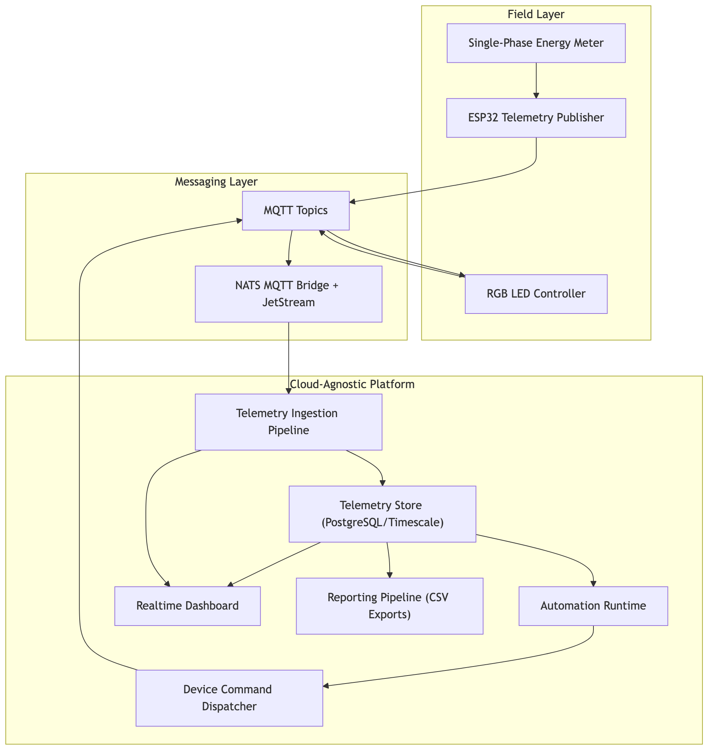
Telemetry is received by the flow on broker subjects, undergoes a staged validation and transformation and is stored as canonical logs. Automation is matched with persistent events. Workflows are matched with query and condition nodes, and command payloads are dispatched where the condition is true. The feedback of devices is compared with the command lifecycle records. Simultaneously, historical telemetry is read and translated to asynchronous CSV outputs by the reporting pipeline, which tracks the run-state.
This is a single support-based canonical telemetry substrate that simultaneously supports dashboards, automation, and reporting. Because of this fact, control and analytics do not require different layers of truth in a team.

3.4 All-in-One Platform Positioning (Balanced Comparison)
The initial thesis involved an order of layers that was composed of broker, visual flow tooling, timeseries storage, and external dashboards. The architecture adopted put the latter issues within a single platform boundary.
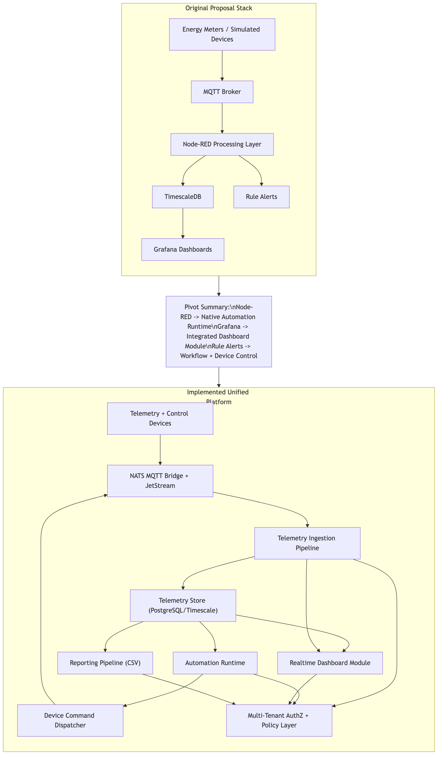
Operational coherence is the strategic reason behind this decision, rather than preference of the tools. The architecture of a fragmented architecture introduces synchronization work per integration seam: schema mapping, access policy alignment and duplicate runtime observability configuration. These can be handled in small demonstrations, but once organisations, devices, and workflows are large they become costly.
The project was successful in providing a single user experience and governance boundary through the workflow runtime, workflow control dispatch, dashboarding and reporting all in a single system. This also minimised the reliance on independently managed tooling stacks which may also create additional scale related licencing, operational, or coordination expenses. The report thus outlines the system implemented as a universal operational platform without making any absolute statements of inapplicability of external tools.

3.5 ESP32 Firmware Architecture: Device Modules + Common Runtime.
The decision to present the behaviour of firmware in two layers was one of the important implementation decisions.
One of the standard patterns of runtime that are utilised across devices is the first layer. This layer is concerned with the WiFi bootstrap, brokering connexion, MQTT session life cycle, the Last Will and Testament (LWT), presence publication, reconnect behaviour, and publish retry time. It also provides a periodic telemetry envelope and diagnostic field to make sure that payloads are structure by the platform on a periodic basis.
The second level is device specific logic. In this project, there is a single module to governing the actuator behaviour and command acknowledgment semantics of RGB. The other module is to obtain single-phase metre through RS485 Modbus and broadcast telemetry.
This isolation is very important in maintainability. It allows teams to simply add new sensor or actuator classes, and not to rerun the connectivity and session-management logic many times. It also enhances consistency of the operation since the lifecycle behaviour is standardised between the device fleet firmware.
In implementation terms, the runtime contract is expressed through reusable lifecycle hooks: deviceSetup(), deviceLoop(nowMs), and onControlMessage(payload). The connectivity layer gives rise to and imposed network state, and the device modules are worried with business logic and data transformation. With actuator devices, the control hook utilises command payloads and provides state acknowledgements. v1 control hook The control hook in v1 is essentially non-executable and forces behaviour to be explicitly read-only and avoid unsafe side effects as much as possible on the metre path. This model is dedicated to gradual firmware development because write-oriented controls can be added to it in the later stages without requiring the redefinition of a communication lifecycle. It also gets more testable: without sensor parsing, reconnect, heartbeat and publish behaviour can be tested.

3.6 Actuator Firmware Module (RS274)
The RGB firmware path is the control-side evidence point. It is subscribing to control subjects, enacts payload parameters such as power, brightness, colour and effect and publishes state changes. The feedback on the observed lifecycle of the command is reconciled on the platform so as to determine the success based on the observed feedback rather than the attempt to publish.
Figure 3 above is an automation DAG of a query and condition node to convert metre telemetry to an RGB alert command.
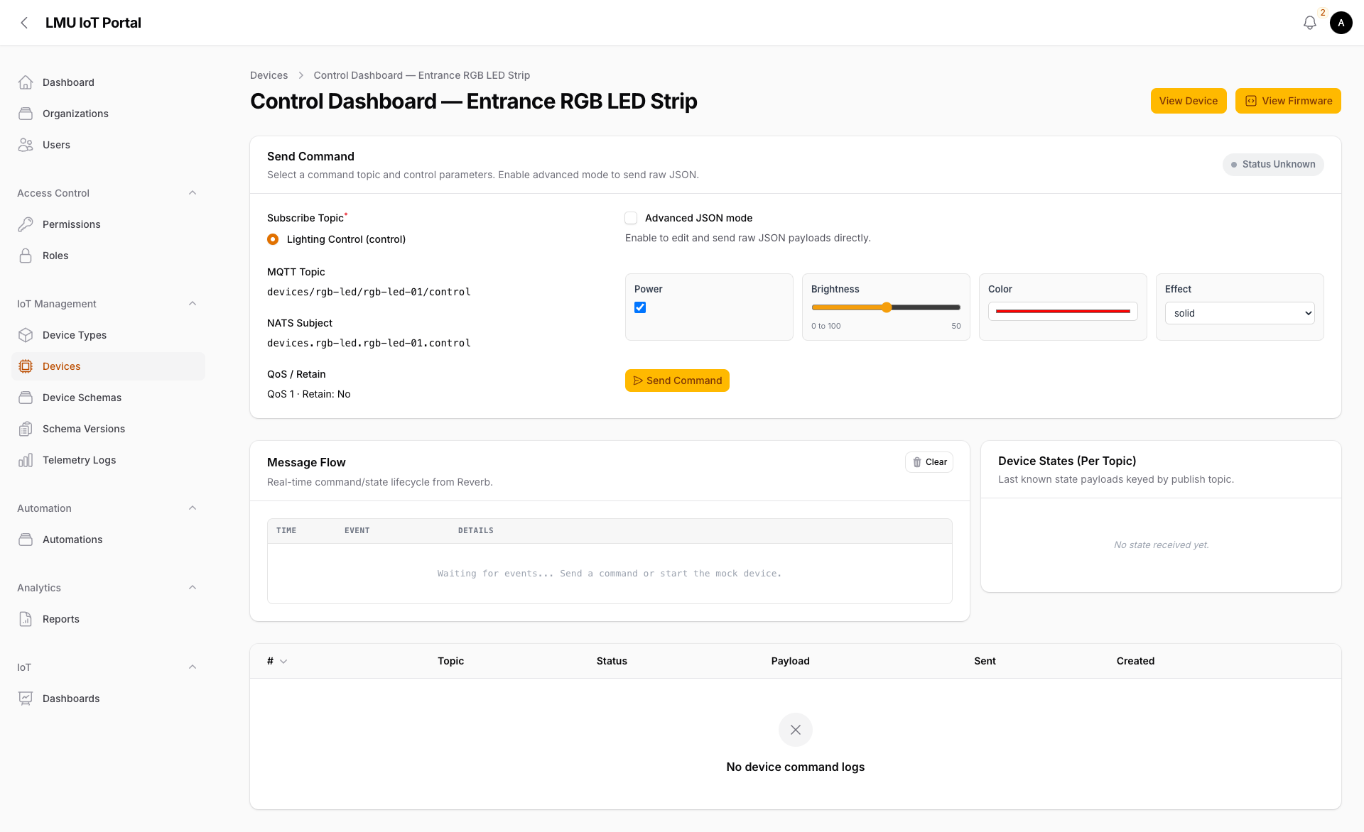
This module illustrates the deterministic control semantics and bridges the gap between workflow decisions and the behaviour of physical devices.

3.7 Single-Phase Meter Firmware Module (PZEM RS485)
This implementation is modified to reach an edge layer farther than the actuator path by using an ESP32 firmware path to use PZEM-014/016 single-phase metering over RS485-UART. The communication profile in the manual is a Modbus RTU over UART with 9600 baud, 8 data bits, 1 stop bit, no parity, and with the measurement read on the function number 0x04.
The v1 polling command reads 10 registers of frame intent 01 04 00 00 00 0A CRC starting at address 0x0000 to 0x0009 in Modbus ordering where the anticipated low/high pair of CRC16 values of this request are 70 0D. Response length and CRC are checked by the firmware and then scaling is implemented. The decoded telemetry set includes:
- Voltage (0x0000) at 0.1 V resolution.
- Current (0x0001 low + 0x0002 high) at 0.001 A resolution.
- Active power (0x0003 low + 0x0004 high) at 0.1 W resolution.
- Energy (0x0005 low + 0x0006 high) in Wh, published as kWh.
- Frequency (0x0007) at 0.1 Hz resolution.
- Power factor (0x0008) at 0.01 resolution.
- Alarm status (0x0009).
Write-oriented operations in the manual, such as address updates, alarm threshold writes, and energy reset commands, are intentionally excluded from v1 runtime behavior. They are treated as controlled future enhancements.
To align with schema-driven onboarding, the firmware uses placeholder-based identifiers and topics ({{DEVICE_ID}}, {{MQTT_CLIENT_ID}}, {{TELEMETRY_TOPIC}}, {{STATE_TOPIC}}, {{PRESENCE_TOPIC}}). Published payload keys include voltage_v, current_a, active_power_w, frequency_hz, power_factor, total_energy_kwh, alarm_status, and read_ok, with optional diagnostics such as modbus_error, poll_ms, and fw_version.

3.8 Ingestion, Automation, and Control Logic
Ingestion is performed on the platform side as a staged processing followed by validation and mutation gates and subsequent persistence. Queue-backed workers handle asynchronous workloads and isolate ingestion spikes from downstream execution pressure (Laravel, n.d.-a; Laravel, n.d.-b).
The demonstration automation computes 15-minute consumption by windowed delta over cumulative energy (MAX(total_energy_kwh) - MIN(total_energy_kwh) in interval). This is followed by a threshold condition which makes the decision whether to send an RGB alert command. The sensitivity to single-sample noise in this selection of bounded-window logic is minimised, and the scalability to operation decision times is matched.
Command Lifecycle Tracing Each decision branch is traced by run-step records and command lifecycle status.

3.9 Dashboard and Reporting
The dashboard layer supports historical and realtime views for voltage, energy, and current variables.
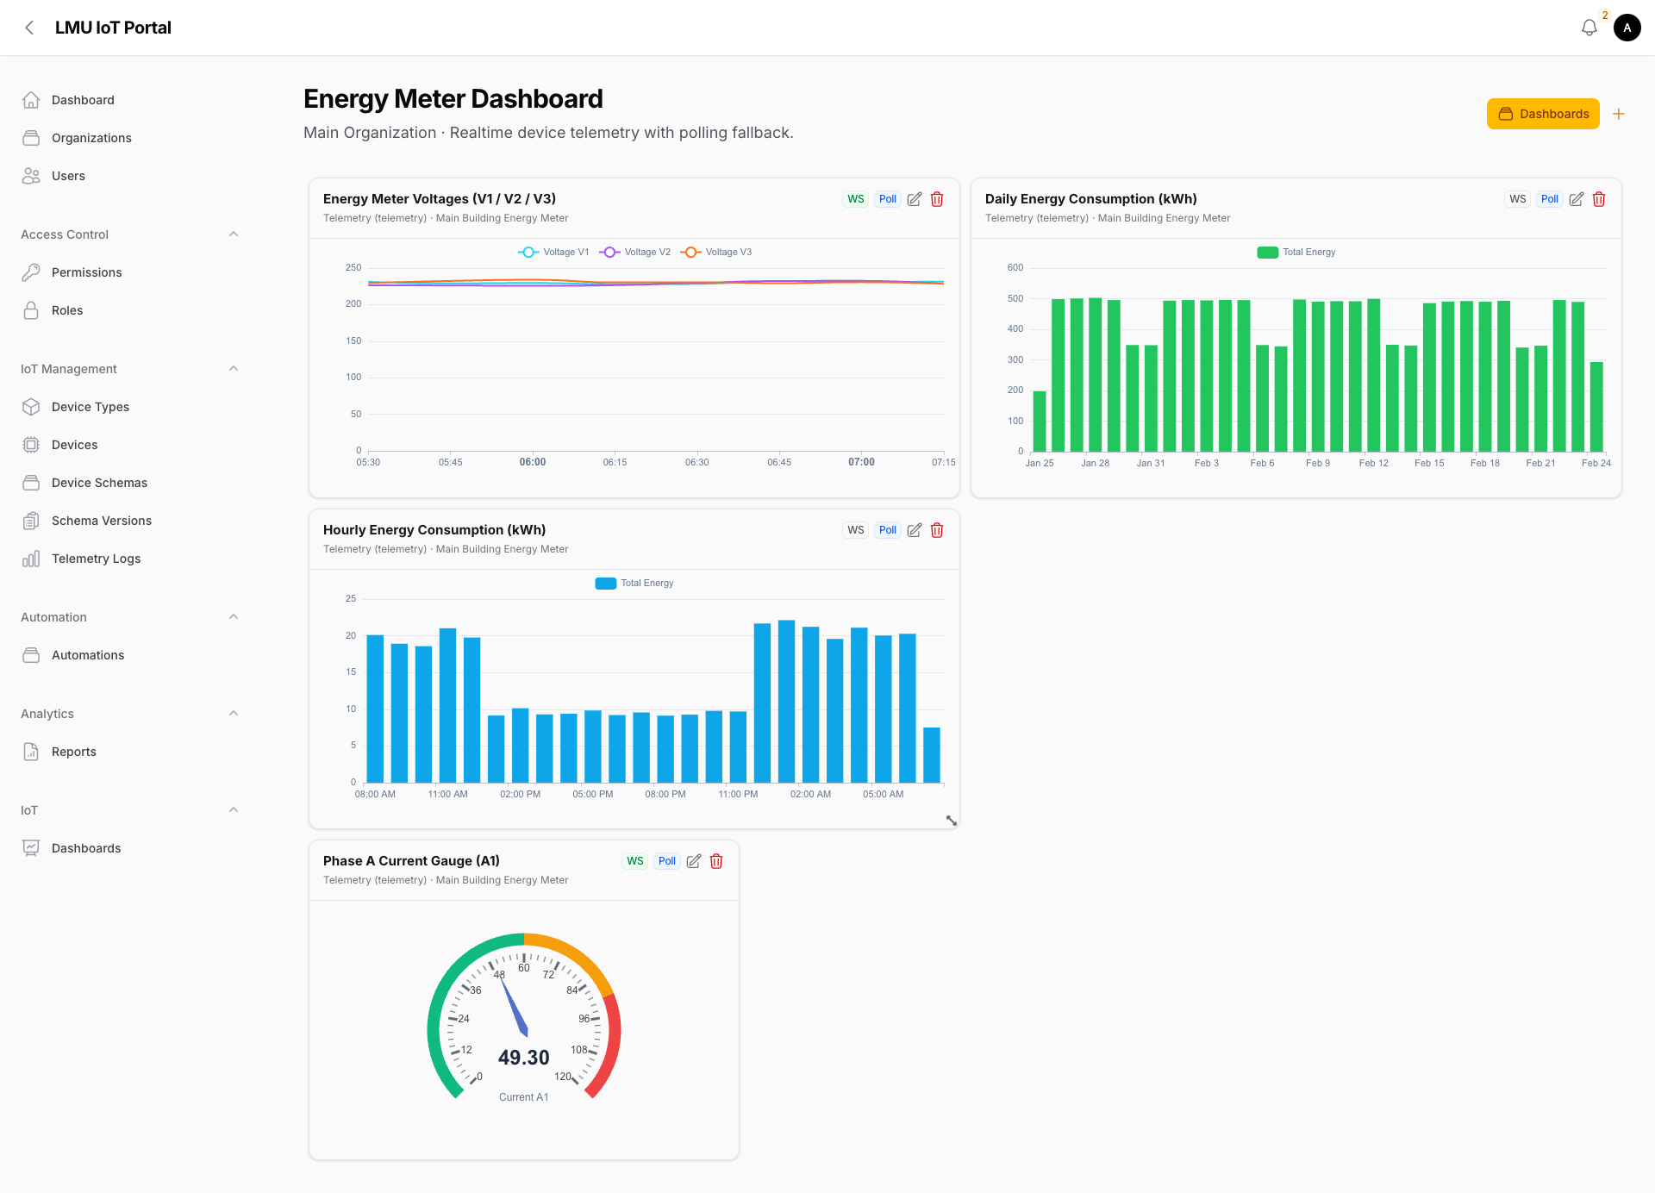
Realtime delivery uses broadcast channels with polling fallback to maintain continuity under variable network conditions (Laravel, n.d.-c; Laravel, n.d.-d).
The reporting module adds asynchronous CSV exports with queue visibility and lifecycle states (queued, running, completed, no_data, failed).
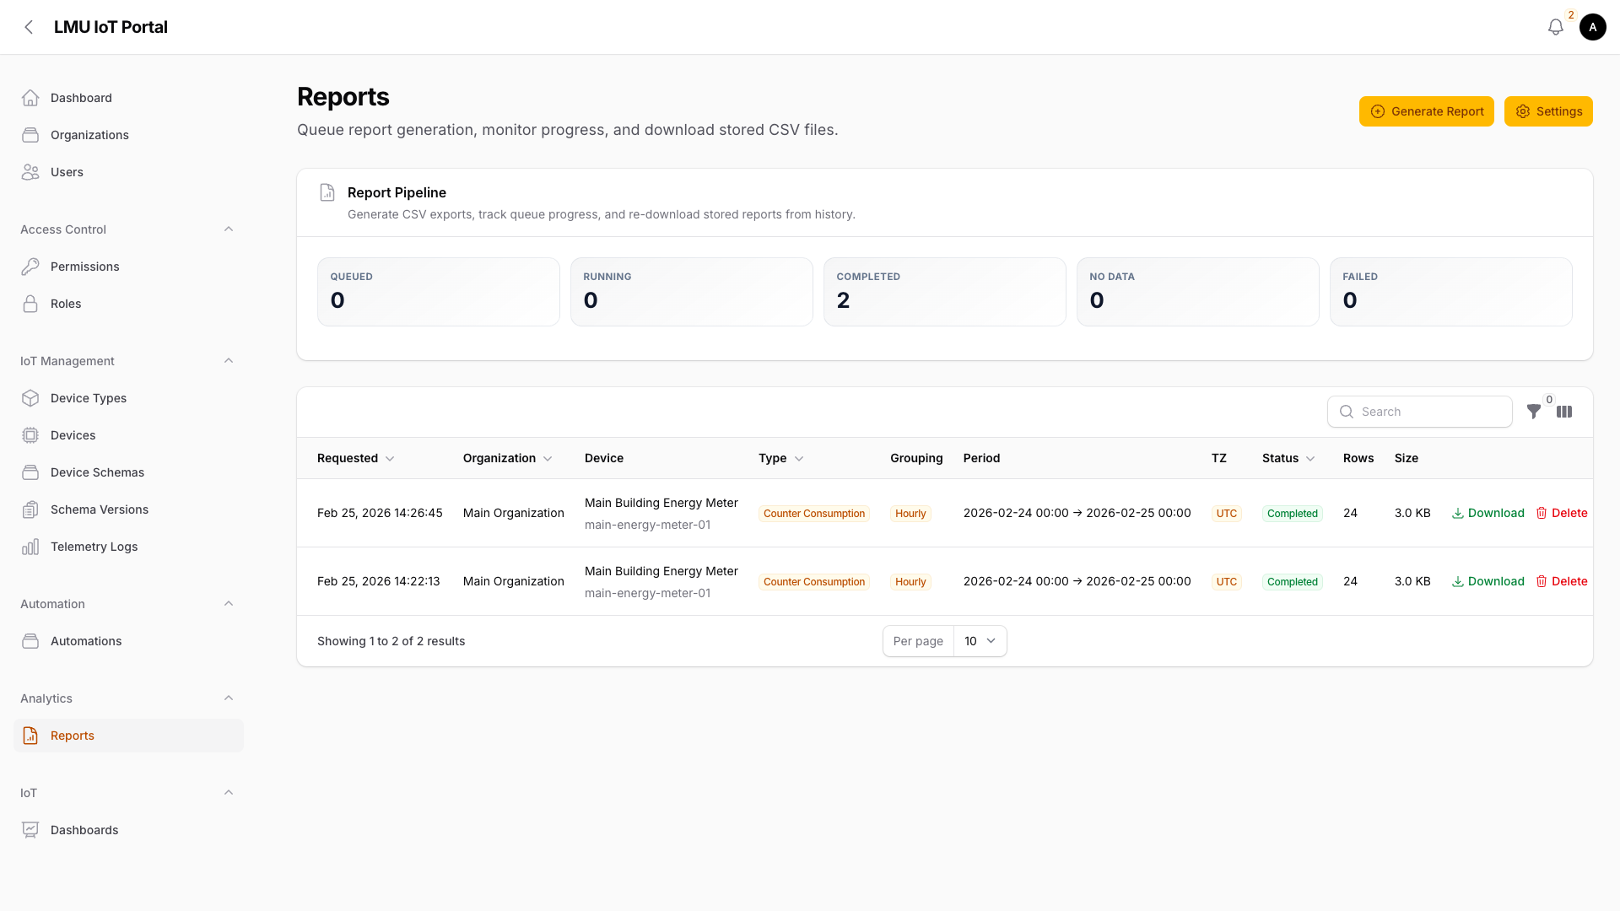
This architecture turns telemetry into both operational feedback and auditable analytical artefacts.

3.10 Cloud-Agnostic Deployment and Kubernetes Scalability
The solution is cloud-neutral since core processing logic will be based on portable containerized services and open protocol/data interfaces instead of vendor-specific runtime capabilities. Kubernetes provides the orchestration model for scaling independent workloads such as ingestion workers, automation workers, realtime services, and reporting jobs (Kubernetes Authors, n.d.-a; Kubernetes Authors, n.d.-b).
In the case of Azure deployment, AKS is an operation of managed Kubernetes, but it maintains this portability model (Microsoft, n.d.).
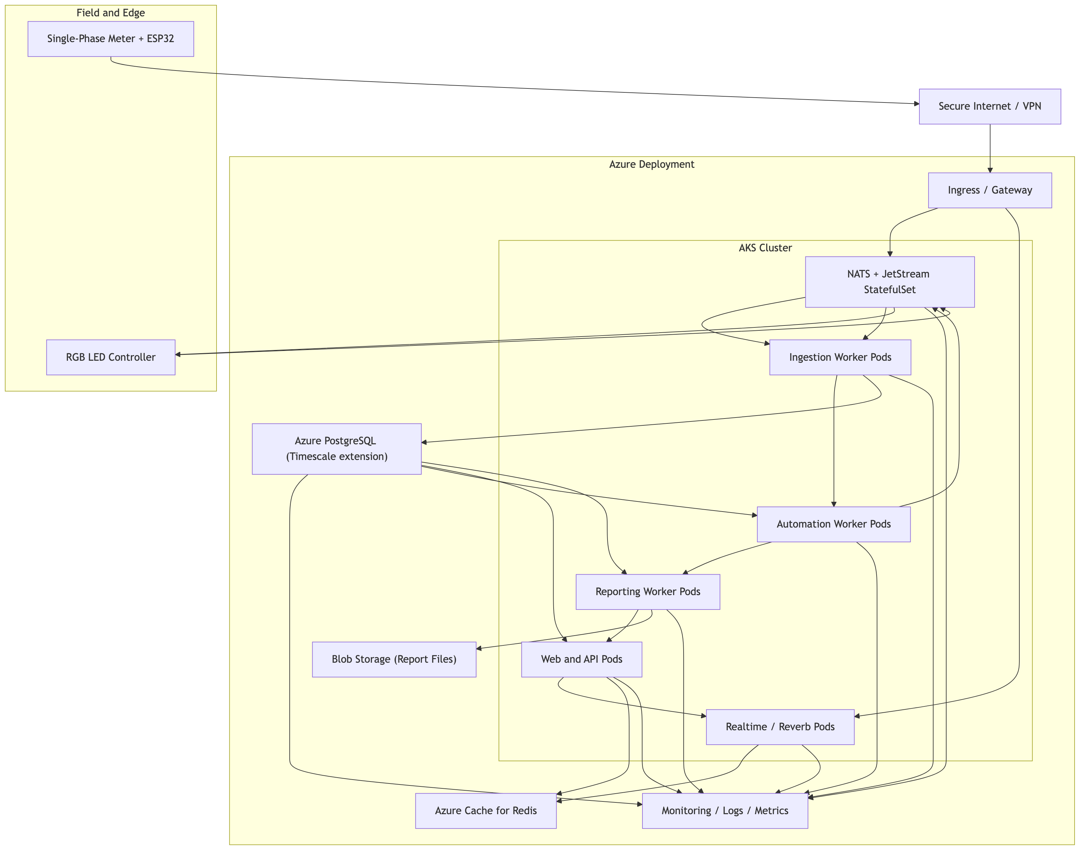

3.11 Evaluation and Validation
Correctness and traceability was put forward in validation as opposed to speculative performance claims.
Telemetry ingestion, query output, condition pass, command dispatch and feedback reconciliation could be examined using run-step and command records in positive-path workflow scenarios. In negative-path cases, threshold failure successfully avoided side effects of the actuators.
In the meter firmware path, we specified validation criteria at protocol, runtime levels: request frame structure, validation of the CRC, validation of the response bytes, scaling correctness, correctness of the timeouts, and recoverability on malformed frames which caused no crash. On connectivity, the firmware restarted, reconnect and presence restoration were expected.
At platform-contract level, payload validation required that total_energy_kwh be present and numeric, because this field is central to the 15-minute consumption workflow.
Operation edge cases, which are prevalent in mixed hardware contexts were also validated. These were tested in cases of transient interruption of the connexion to the broker in active polling windows, sluggish serial response by the RS485 bus and invalid reply buffers with correct headers and invalid CRC tails. In both cases, degradation was expected to be controlled (instead of a workflow stop); that is, mark read ok false, maintain runtime loop continuity, publish diagnostics and recover in a later valid cycle. This is important behaviour needed to be production-ready due to avoiding false assumptions of devices going dead when the actual cause is a temporary burst of transport noise.

3.12 The AI-Assisted Development Methodology.
As an implementation aid, GPT-Codex and Claude Opus served as engineering aids in code fragment writing, proposals of firmware structure, and report structure. The project team did final technical decisions, integration and validation. The output of AI was not considered as an authoritative outcome but as a draught content. This workflow was employed in order to speed up the iteration and keep the human responsibility to make sure everything was correct and systems acted like it should.

4 Conclusion
The project established a full loop of energy monitoring to action on a cloud-based IoT platform. The presented system consumes single-phase telemetry, calculations of bounded-window energy behaviour, deterministic automation, actuator commands dispatched, device feedback reconciled, and realtime dashboards as well as asynchronous reporting outputs exposed.
The architectural turn between a toolchain that was disjointed to a platform enhanced operational coherence without functional narrowing. The solution was better suited to scale growth after pilot scale due to a common UX, governance boundary, and contract-based onboarding model of devices.
This foundation is enhanced by the introduction of standardisation of the firmware architecture. A common ESP32 run-time format, along with device-specific modules, allows reuse and defined extension. This approach of sensor-side acquisition is illustrated by the new PZEM RS485 metre path, which does not interfere with existing automation logic.
In general, the platform offers a functional, cloud-agnostic foundation of scaling the energy IoT operations in which traceability, interoperability, and operational simplicity are the priorities.

5 Recommendations
- Harness controlled write-path support of address/alarm/reset operations of PZEM behind authorization and audit controls.
- Include long duration ingestion and websocket load testing to measure throughput and latency when conditions are realistic fleet.
- Add adaptive anomaly thresholds with deterministic rule fallback on critical workflows.
- Test regression safety Expand firmware contract test and hardware-in-the-loop validation of device variants.
- Specify tenant-level Kubernetes resource policies and autoscaling guardrail in large multi-organization deployments.

6 Limitations
- Modern validation focuses on functional correctness and traceability as opposed to complete benchmark characterization.
- The meter firmware v1 is read-only and is not yet made to reveal controlled write actions.
- The present report does not include security/compliance hardening.
- The artefacts of manual images in the appendix are evidence-based and are not substitutes of vendor primary documentation.

7 Reflection
The greatest learning experience during this project is that the architecture decisions have a greater impact on long-term operability than short-term feature velocity. There was a temptation to optimise the project in the early stages to combine individual tools that are familiar as soon as possible. That method can provide a demo, but also introduces an additional coordination load that only scales poorly once devices and users are introduced.
Ingestion, automation, control, and visualization, as well as reporting within a single platform boundary, allowed the team to lessen the ambiguity of integration and made operations ownership simpler. This necessitated a more careful domain modeling, but it was compensated in maintainability and traceability.
The second learning outcome was the pivotal position of the clarity of the firmware contract. The fact that common connectivity/runtime issues were no longer mixed with device logic and behaviour ensured it was easier to reason about their behaviour and plan new device onboarding. This advantage was augmented by the PZEM addition because it demonstrated that protocol-specific acquisition can be added without the need to redesign platform-side automation.
Another aspect that the team found out is that reporting is not an ancillary attribute. Live dashboards facilitate real-time decision-making, yet operations and governance should have long-lasting exports and run histories to be accountable. The fact that reporting is a first-class workflow made the platform more useful practically.
Lastly, AI-enhanced development proved to be effective in terms of being fast, however, it had to be closely followed by human inspection and validation. The project reiterated that engineering work could be fastened with the use of tooling, but the implementation team should still perform the correct job.

8 References
Espressif Systems (n.d.) ESP32-S3 series. Available at: https://www.espressif.com/en/products/socs/esp32-s3 (Accessed: 25 February 2026).
Kubernetes Authors (n.d.-a) Overview: What is Kubernetes? Available at: https://kubernetes.io/docs/concepts/overview/what-is-kubernetes/ (Accessed: 25 February 2026).
Kubernetes Authors (n.d.-b) Autoscaling workloads. Available at: https://kubernetes.io/docs/concepts/workloads/autoscaling/ (Accessed: 25 February 2026).
Laravel (n.d.-a) Queues (Laravel 12.x documentation). Available at: https://laravel.com/docs/12.x/queues (Accessed: 25 February 2026).
Laravel (n.d.-b) Horizon (Laravel 12.x documentation). Available at: https://laravel.com/docs/12.x/horizon (Accessed: 25 February 2026).
Laravel (n.d.-c) Broadcasting (Laravel 12.x documentation). Available at: https://laravel.com/docs/12.x/broadcasting (Accessed: 25 February 2026).
Laravel (n.d.-d) Reverb (Laravel 12.x documentation). Available at: https://laravel.com/docs/12.x/reverb (Accessed: 25 February 2026).
Microsoft (n.d.) What is Azure Kubernetes Service (AKS)? Available at: https://learn.microsoft.com/en-us/azure/aks/what-is-aks (Accessed: 25 February 2026).
MQTT.org (2024) MQTT specifications. Available at: https://mqtt.org/mqtt-specification/ (Accessed: 25 February 2026).
NATS (n.d.-a) Subject-based messaging. Available at: https://docs.nats.io/nats-concepts/subjects (Accessed: 25 February 2026).
NATS (n.d.-b) MQTT configuration. Available at: https://docs.nats.io/running-a-nats-service/configuration/mqtt (Accessed: 25 February 2026).
NATS (n.d.-c) JetStream concepts. Available at: https://docs.nats.io/nats-concepts/jetstream (Accessed: 25 February 2026).
Peacefair (n.d.) PZEM-014/016 AC communication module manual (project-supplied device documentation).
PostgreSQL Global Development Group (2025) JSON functions and operators. Available at: https://www.postgresql.org/docs/current/functions-json.html (Accessed: 25 February 2026).
Tiger Data (n.d.) Hypertables. Available at: https://docs.timescale.com/use-timescale/latest/hypertables/ (Accessed: 25 February 2026).

9 Appendices

9.1 Appendix A: Firmware Listing (RGB Actuator)
Full firmware listing location:
- plan/DeviceControlArchitecture/esp32-rgb-light/esp-32-rgb-light.ino
The RGB module demonstrates command subscription, effect application, state publication, and presence lifecycle behavior.

9.2 Appendix B: Firmware Listing (Single-Phase Meter via RS485)
Full firmware listing location:
- plan/DeviceControlArchitecture/esp32-single-phase-energy-meter/esp32-single-phase-energy-meter.ino
This module demonstrates Modbus RTU measurement polling and telemetry publication using the shared connectivity/runtime pattern.

9.3 Appendix C: PZEM Manual Evidence and Protocol Extraction
Formatting and interpretation in firmware are based on the project-supplied PZEM-014/016 manual pages.
Manual evidence figures (appendix-only):
Extracted register map used in firmware v1:
Register | Meaning | Resolution used in firmware
0x0000 | Voltage | raw * 0.1 V
0x0001 + 0x0002 | Current (low/high) | combined * 0.001 A
0x0003 + 0x0004 | Active power (low/high) | combined * 0.1 W
0x0005 + 0x0006 | Energy (low/high) | combined Wh → /1000 kWh
0x0007 | Frequency | raw * 0.1 Hz
0x0008 | Power factor | raw * 0.01
0x0009 | Alarm status | direct integer/status flag
Modbus read frame baseline validated for firmware:
- Request intent: 01 04 00 00 00 0A CRC
- CRC16 low/high bytes expected for this request: 70 0D

9.4 Appendix D: Final Formatting Notes for Submission
For final academic formatting consistency with the sample style:
- Use Times New Roman.
- Use black font color throughout.
- Use justified paragraph alignment.
- Use numbered heading hierarchy on A4 page layout.

